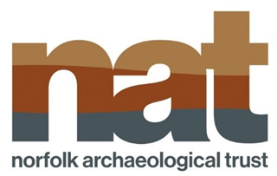
Report to Horning Parish Council AGM May 2023.
A haven for wildlife, peace, and tranquility
St Benet’s Abbey provides calm and tranquility, connecting its visitors to an ancient religious site, and beautiful Norfolk Landscape.
The Bishop of Norwich, to this day remains the Abbot of St Benet’s Abbey as, remarkably, King Henry VIII dissolution was not applied to St Benet’s Abbey, the single monastery across the whole of England to avoid having its assets seized by the crown. On Sunday 30th July 2023 Bishop Graham Usher will celebrate his annual service here
Today, nature lovers, bird watchers, photographers, artists, anglers, walkers, and visitors to the site enjoy its ambience and opportunity for creativity and wellbeing as well as its glorious surroundings.
Norfolk Archaeological Trust would like to thank all the volunteers who freely give their time and energy to ensure that this site remains beautiful and safe for visitors. Our volunteers ensure the site is litter free, monitor any deterioration in the structure, offer guided tours and ensure that every visitor has the best experience whilst on the site.
NAT has recently appointed a new Visitor Experience Manager, Fran Young, and her remit includes supporting the current volunteers. She also wants to work with the wider community to ensure that the site is valued and utilised by those who live and work close to this precious heritage site.
More volunteers will ensure sustainability at the site, and anyone who is interested in supporting our work can contact us via our website-
https://www.norfarchtrust.org.uk/support-us/

Join the Norfolk Archaeological Trust and help us continue our unique work.
In return for your membership subscription, you will receive each year an illustrated Annual Report on the work of the NAT prior to the AGM, and a Spring Newsletter. You will receive monthly e-newsletters on NAT activities and forthcoming events, and you will be able to take part in special guided tours of new NAT properties as we acquire them. As a member you will also be able to hear a first-hand account of our work at the AGM and hear an interesting talk from an invited speaker.
We will be able to make Gift Aid claims on your subscriptions and donations to HM Revenue and Customs if you are a British taxpayer.
Annual Membership currently costs £25, or £500 for Life Membership

