HORNING PARISH COUNCIL

Minutes of a Parish Council Meeting
held on Monday 7th December 2020 at 1900 hrs on Zoom

Present:
Cllr I Davis (Chairman)
Cllr P Avellino
Cllr P Iddon
Cllr A Varley

Clerk / RFO: Jo Beardshaw

Number of Parishioners: 4

- Apologies. Cllrs Darby, Seddon and Martin had sent their apologies, which were accepted. Cllr Cavendish had not attended the meeting
- Declarations of Interest. Cllr Varley noted an interest on the basis that he sits as a District Cllr on the Planning Committee at the District Council
- Minutes of the previous meeting.
  - To receive and approve the minutes of the Zoom meeting held on Monday 2nd November 2020, and matters arising. APPROVED
  - To receive and approve the minutes of the Finance Committee meeting held on Monday 16th November. APPROVED

- Actions from previous minutes: None to report
- Correspondence
  - PKF Littlejohn. Receipt of completion of audit paperwork, and to note ‘except for’ matters on the External auditor report and certificate for the financial year 2019/20. The Council noted that the RFO should in future sign Section 2 prior to approval by the Council.

- Finances:
  - Cllr Davis confirmed the accounts for the month

  - Receipts:
    - None

  - The following payments were authorised:

Date | Payee | Description | Chq No | Amount | VAT
7.12.20 | Ralph Morris | Litter Picking | S/O | 130.00
7.12.20 | Clerk | Salary and expenses | 2528 | 565.92
7.12.20 | Horning Parish Council | To open Unity Trust bank account | 2529 | 500.00
24.11.20 | URM | Glass | DD | 32.22 | 5.37
3.12.20 | NEST | Pension (£47 of which paid by Clerk) | DD | 105.66
7.12.20 | HMRC | November and December Tax | 2530 | 95.60
7.12.20 | NNDC | Dog bins | 2531 | 2423.40 | 403.90
7.12.20 | PKF Littlejohn LLP | External audit | 2532 | 240.00 | 40.00
7.12.20 | Carol Gilden | Green and sign cutting | 2533 | 155.00
7.12.20 | Keith Buck | Slipway maintenance works | 2534 | 40.00

- Asset Management.
  - Cllr Varley noted that there was a complaint regarding an advertising board on the village green but that it had not been in use since the complaint. Cllr Avellino noted that the local contractor had cut the hedge on the slipway and would change the bulb on the light on the Village green. Cllr Avellino also noted that Cllr Darby had arranged for a new uplighter on the Oak Tree.
  - There was some discussion regarding Christmas Lights and the Christmas Tree, which were organised by the PCC and villagers. The Council thanked Cllr Darby for his work on the lights.

- Parish Councillor reports.
  - Playground report (new inspection book to be handed from Cllr to Cllr). Cllr Varley had conducted the report for the month
  - Chairman. Research regarding registration with the Information Commissioner’s Office. The Chairman confirmed that, following research, the Council should register with the ICO and that the Clerk would review the GDPR requirements again in the coming months. The payment to the ICO would be £40 annually

- Parishioners’ Matters: The meeting was adjourned at 1925 hrs for public participation
  - District / County Councillor report. Cty Cllr Price had attended the meeting and gave a report on the recent Ferry Road meeting, and the current C-19 situation
  - Cllr Varley gave a report in his capacity as District Councillor

  - Public Session

The meeting was reconvened at 1935

- Planning:
  - Planning applications received
    - BA/20/0389/COND. 3 Bureside Estate, Still Waters, Crabbetts Marsh. Removal of upper floor of approved extension, variation of condition 2 and removal of condition 6 of permission BA/2019/01299/HOUSEH. Supported
    - BA/2020/0384/FUL: Proposed replacement boathouse, boardwalk and mooring. Boathouse, Ferry Cott Lane, Horning, Norwich. Supported prior to meeting due to timescale

- Agenda items
  - To consider fidelity insurance for the financial year 2021/22. It is required (LGA 1972) that local councils take such ‘security’ as it considers adequate against loss by reason of the acts of any employee who handles money or property. A Council may decide that no insurance is sufficient to cover this but it must justify the decision. The Council AGREED that it was NOT necessary to take out fidelity guarantee insurance on the basis that the Clerk deals with very small quantities of money (from allotment tenants / slipway income)
  - To consider the recommendation as follows from the Finance Committee meeting held on Monday 16th November, and to approve a precept request figure for the f/y 2021/2022. The Parish Council APPROVED the budget as per the finance committee recommendation, and AGREED a precept of £19,265. The Clerk would inform NNDC of the Council’s decision
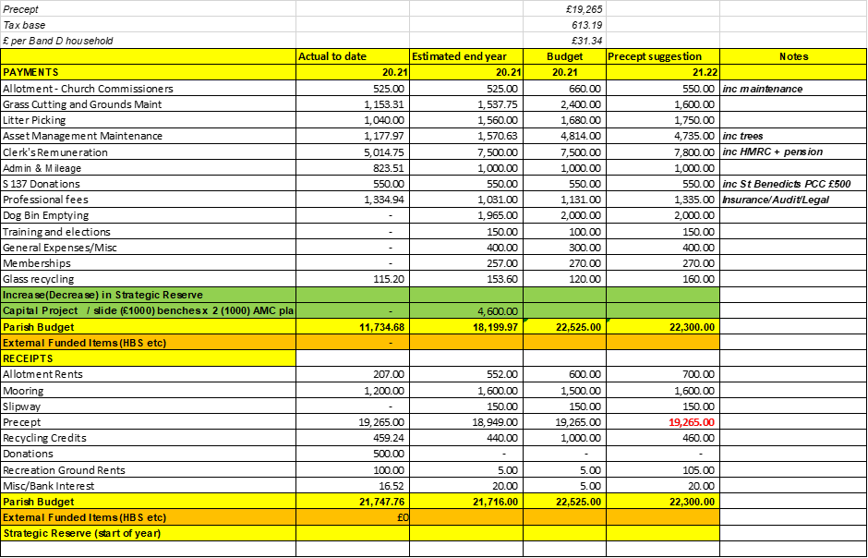

- To list items for the Horning Reach Parish News
  - Census 2021. March 21st
  - Ferry Road meeting
  - Dog mess on the recreation ground

- To identify other items at the Chairman’s discretion: None
- To identify the next venue for the SAM2 sign. The Sam2 sign would be placed at Swan Corner
- To confirm that the next meeting will take place on Monday 4th January 2021 on Zoom at 7pm
- Closure of meeting at 1950 hrs

