local council award scheme foundation

**NOTICE OF A PARISH COUNCIL MEETING**

**To Members of the Council**: You are hereby summoned to attend a Horning Parish Council **Meeting ON ZOOM** on **Monday 7th December 2020 at 7pm**  for the purpose of transacting the following business:  
Jo Beardshaw Parish Clerk / RFO

Jo Beardshaw is inviting you to a scheduled Zoom meeting.

Join Zoom Meeting

https://us02web.zoom.us/j/6049531728

Meeting ID: 604 953 1728

To telephone meeting: 0203 481 5237

**Press and Public are welcome**

**AGENDA**

1. **Apologies for absence**
2. **Declarations of Interest.** Members are invited to declare personal or prejudicial interests in items on the agenda. It is a requirement of the Parish Council’s (Model Code of Conduct) Order 2001 S8 that declarations from a member include the nature of the interest and whether it is personal or prejudicial
3. **Minutes of the previous meeting**

To receive and approve the minutes of the meeting held on Monday 2nd November, and matters arising.

(Finance Committee): To receive and approve the minutes of the Finance Committee meeting held on Monday 16th November

1. **Actions from previous minutes**

To report any actions and updates from previous minutes

1. **Correspondence**
   1. PKF Littlejohn. Receipt of completion of audit paperwork, and to note ‘except for’ matters on the External auditor report and certificate for the financial year 2019/20
2. **Finance**
   1. To receive confirmation of finances
   2. To note receipts

None

* 1. To agree and authorise payments

|  |  |  |  |  |  |
| --- | --- | --- | --- | --- | --- |
| **Date** | **Payee** | **Description** | **Chq No** | **Amount** | **VAT** |
| 7.12.20 | Ralph Morris | Litter Picking | S/O | 130.00 |  |
| 7.12.20 | Clerk | Salary and expenses | 2528 | 565.92 |  |
| 7.12.20 | Horning Parish Council | To open Unity Trust bank account | 2529 | 500.00 |  |
| 24.11.20 | URM | Glass | DD | 32.22 | 5.37 |
| 3.12.20 | NEST | Pension (£47 of which paid by Clerk) | DD | 105.66 |  |
| 7.12.20 | HMRC | November and December Tax | 2530 | 95.60 |  |
| 7.12.20 | NNDC | Dog bins | 2531 | 2423.40 | 403.90 |
| 7.12.20 | PKF Littlejohn LLP | External audit | 2532 | 240.00 | 40.00 |
| 7.12.20 | Carol Gilden | Green and sign cutting | 2533 | 155.00 |  |
| 7.12.20 | Keith Buck | Slipway maintenance works | 2534 | 40.00 |  |

1. **Asset Management.** To receive the report from the Asset Management Committee
   1. Update on picnic bench request from parishioner
2. **Parish Councillor reports.** To receive any Parish Councillor reports and updates, including:
   1. Chairman. Research regarding registration with the Information Commissioner’s Office

1. **Parishioners’ Matters**

To adjourn the meeting to allow members of the public to speak for a maximum of 5 minutes

* District Councillor / County Councillor
* Members of the public to speak
* Reconvene meeting

1. **Planning.** 
   1. Planning applications received
      1. BA/20/0389/COND. 3 Bureside Estate, Still Waters, Crabbetts Marsh. Removal of upper floor of approved extension, variation of condition 2 and removal of condition 6 of permission BA/2019/01299/HOUSEH.
      2. BA/2020/0384/FUL: Proposed replacement boathouse, boardwalk and mooring. Boathouse, Ferry Cott Lane, Horning, Norwich. Supported prior to meeting due to timescale
2. **Agenda items. To discuss agenda items**
   1. To consider fidelity insurance for the financial year 2017/18. It is required (LGA 1972) that local councils take such ‘security’ as it considers adequate against loss by reason of the acts of any employee who handles money or property. A Council may decide that no insurance is sufficient to cover this but it must justify the decision.
   2. To consider the recommendation as follows from the Finance Committee meeting held on Monday 16th November, and to approve a precept request figure for the f/y 2021/2022

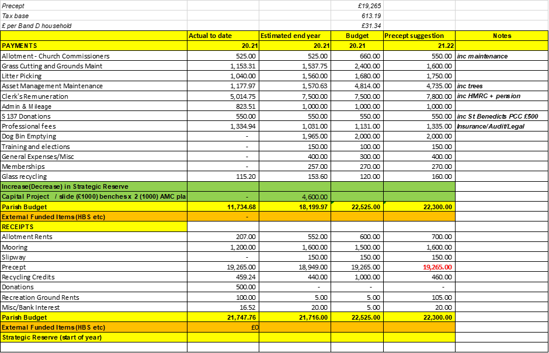

1. **To list items for the Horning Reach Parish News** 
   1. Census 2021. March 21st
2. **To identify other items at the Chairman’s discretion**
3. **To identify the next venue for the SAM2 sign**
4. **To confirm that the next meeting will take place on Zoom at 7pm on Monday 4th January at 7pm**
5. **Closure of meeting**