**HORNING PARISH COUNCIL**

**HHHHMinutes of a Parish Council Meeting**

**held on Monday 3rd December 2018 at 7pm in St Benet’s Hall**

**Present:**

**Cllr P Iddon**

**Cllr A Seddon**

**Cllr A Varley**

**Cllr P Avellino**

**Cllr K Horey**

**Cllr G Mancini-Boyle**

**Cllr K Rolfe**

**Cllr A Darby**

**Clerk / RFO: Jo Beardshaw**

**Number of Parishioners: 10**

1. **Apologies.** Cllrs Martin, Davis and Smith had sent their apologies, which were accepted
2. **Declarations of Interest.** None

**Minutes of the previous meeting.** To receive and approve the minutes of the meeting held on Monday 5th November 2018, and matters arising.

1. **Actions from previous minutes:**
2. **Correspondence**
   1. NCC Highways. Response to repeater signs or roundels request. The Council **AGREED** that the **Clerk** should put a PP bid in for 2 x roundels at a cost of £150 each (therefore £150 in total for 2 x roundels if the PP bid was successful). Cty Cllr Price then offered to use his own Highways budget to pay for the roundels. **The Clerk** would work this out with NCC Highways and Cllr Price. The Council had agreed on roundels rather than repeater signs as there was already enough street furniture on Lower Street
   2. BA/2018/0468/TPOA. Application for works to trees. Bureside Estate, Plot 28 and 28A. One willow – fell. Noted
   3. NCC Highways. Note that NCC will refill salt bins over the following few weeks. Noted
   4. Anglian Water – feedback requested. The Council agreed that the current activities of Anglian Water were fairly low key and were not impacting on the village
   5. BA/2018/0443/TPOA. T1 and T2. Plots 38 and 39. Crabbetts Marsh. Ash Removed. Noted
3. **Finances:**
   1. To receive confirmation of finances. Cllr Martin had signed the bank reconciliation for August
   2. The following receipts were noted:
      1. Horning Boat Show Community Fund Awards. £5,000 Playing Field Play area fencing
      2. Horning Boat Show Community Fund Awards. £1374.31. Jubilee Walk upgrade project
   3. The following payments were authorised:

|  |  |  |  |  |  |
| --- | --- | --- | --- | --- | --- |
| **Date** | **Payee** | **Description** | **Chq No** | **Amount** | **VAT** |
| 15.11.18 | CGM Landscaping | Recreation Ground | S/O | 81.80 | 13.63 |
| 5.12.18 | Clerk | Pension | DD | 97.86 |  |
| 5.12.18 | Ralph Morris | Litter Picking | S/O | 130.00 |  |
| 5.12.18 | Clerk | Salary November | 2382 | 538.03 |  |
| 5.12.18 | HMRC | Tax | 2383 | 47.80 |  |
| 5.12.18 | NGF Leisure Ltd | Fencing (re-write of cheque 2379) | 2384 | 12297.41 | 2049.57 |
| 5.12.18 | St Benet’s PCC | Donation | 2385 | 500.00 |  |
| 5.12.18 | NNDC | Dog bins | 2386 | 2265.12 | 377.52 |
| 5.12.18 | Community Heartbeat Trust | Defib pads | 2387 | 105.60 | 17.60 |
| 15.12.18 | URM | Glass recycling | DD | 16.20 | 2.70 |
| 5.12.18 | Keith Buck | Work on playground | 2388 | 600.00 |  |
| 5.12.18 | Happisburgh Parish Council | Councillor training | 2389 | 80.00 |  |
| 5.12.18 | M Peake | Grass cutting | 2390 | 70.00 |  |
| 5.12.18 | SLCC | Subscription | 2391 | 52.00 |  |

1. **Asset Management.** 
   1. Update regarding playground fencing. Cllr Avellino noted that the playground fencing was in place and was receiving complements from many parishioners. Other Councillors echoed this. It was **AGREED** that the Clerk would progress the signage as quickly as possible and that the signs would be posted to the **Chairman** who would kindly put them up.
   2. To receive a recommendation regarding the Table Tennis table. This work could not be undertaken until the summer so the Council agreed that it would consider the options during 2019.
   3. To confirm purchase of ‘no dogs’ signs for fencing. Confirmed
   4. Cllr Avellino also noted that the spinner was repaired and in place. She also noted that there had been a delay with the disabled bays but that Keith Buck would undertake the work as soon as the weather was appropriate. Councillors noted that when Keith Buck intended to undertake the work he would need to fill in the sign with the correct dates. Noted
2. **Parish Councillor reports.**
3. **Parishioners’ Matters: The meeting was adjourned at 7.57 pm for public participation**
   1. **District / County Councillor report**:
      1. Cty Cllr Price noted that he had seen the fencing and thought that it was wonderful

A member of the public noted that he pathway beside the Bowls Club was churned up and muddy. Cllrs did not in general feel that they could reasonably do anything about it at this stage but that they would keep an eye on the problem

**The meeting was reconvened at 8.10pm**

1. **Planning:** 
   1. **Planning applications received**
      1. BA/2018/0421/FUL. Bureside Estate, Plot 2A. Replacement of wooden storage shed. Council supported this application due to timescales
      2. BA/2018/0382/HOUSEH. Whitegates, 32 Lower Street. Remove existing jetty, widen dyke and install replacement jetty. **Supported**.
   2. **Planning decisions received and noted:**

None

1. **Agenda items**
   1. To confirm the BSF bid for Cradle Swings. Cllr Varley explained the various cradle swing options. The Chairman recommended that the options be emailed round for consideration and then delivered for a decision at the January Parish Council meeting.
   2. To receive a quotation for new village bunting from Cllr Darby. Cllr Darby had undertaken some research and was awaiting some samples in the post. He noted that he anticipated that the bunting would cost in the region of £150. The Council gave Cllr Darby delegated powers to spend up to £250 on the bunting
   3. To meet with members of M&B, who represent the Swan Inn. Alan Mcfarlane (Area Manager) and Faye (the pub manager) had attended the meeting as Martha Ingham (Retail Business Manager) had been unavailable. They spoke at the beginning of the meeting and explained that they were keen to get involved within the local community. They answered various questions and understood that parishioners had suffered from poor communication in the past. They assured the Council that they were committed to ensuring that communication improves and that the pub and the parishioners work on good terms with each other. A member of the public asked when the car park could be tidied up from a gardening perspective. Faye explained that she had contacted a gardening contractor, who would be quoting on the work. It was also noted that staff working at the Swan should park on the car park. Faye assured parishioners that she would remind staff of this. Faye and Alan also confirmed that if the village wished to borrow or use the Swan Car Park for a village event, this would probably be agreed. The discussion closed at 7.32 pm, when the meeting started
   4. To discuss the purchase of a collection box beside the dog bag dispenser with a note saying that the Parish Council anticipates a spend of approx. £600 per year. The Council AGREED that the collection box was not necessary, because members of the public and Councillors all agreed that the bin bags were being stolen rather than used. It was therefore **AGREED** not to replace the next batch of dog bags.
   5. To discuss increasing the Mooring rent at Ludham Bridge. This item would be postponed to the January meeting on the basis that Cllr Davis would present the suggestion
   6. To consider a response to the four options presented by the Western Link Team. The **Clerk** would write to the Western Link team supporting the venture, but not specifying a particular route
   7. To consider a ‘limitation of term of office’ for Senior Parish Council position. The Council agreed that (for the current Council) there would be a recommended maximum term of office of 3 years
   8. To consider the suggested precept recommendation from the Finance Committee:

CONSIDERED:

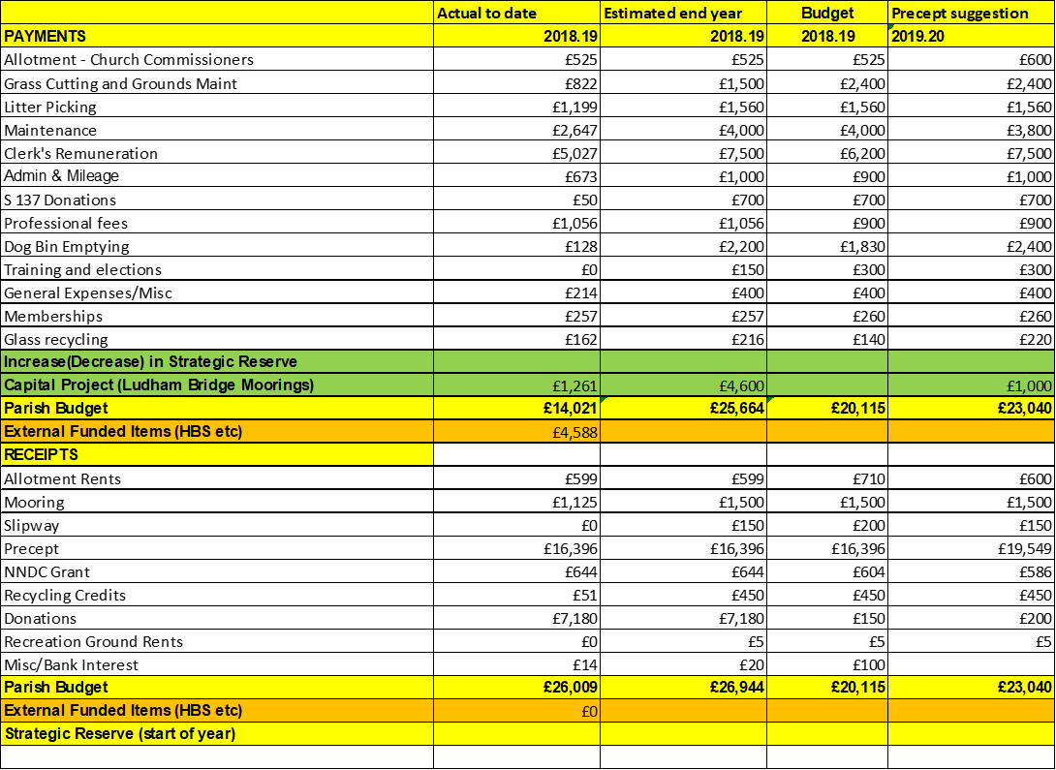

The Parish Council reviewed the precept suggestion from the Finance Committee, and agreed that they were in agreement with all the figures with the exception of the ‘dog bin emptying figure for £2400, which could now be reduced to £1800 on the basis that the agreement had been made to remove the dog bags. **The Clerk** would revert to Cllrs Davis and Martin and would send the required paperwork to NNDC

AGREED:



A PRECEPT of £18,949 was therefore **AGREED**

1. **To list items for the Horning Reach Parish News:**

None

1. **HTo identify other items at the Chairman’s discretion:** 
   1. It was **AGREED** that Cllr Avellino would ask Keith Buck to move the playground bin in the playground towards the gate
2. **To identify the next venue for the SAM2 sign:** Mill Hill
3. **Closure of meeting at 8.45 pm and details of the next meeting:**

**To confirm that the next meeting will take place in St Benet’s Hall at 7pm on Monday 7th January 2019.**