HORNING PARISH COUNCIL

Minutes of the Parish Council Meeting
held on Monday 4th April 2016

Present:
Cllr I Davis (Chairman)
Cllr P Iddon
Cllr A Gilden
Cllr K Smith
Cllr C Smith
Cllr A Darby
Cllr P Kibler
Cllr M Turpin
Cllr P Avellino

Clerk / RFO: Jo Beardshaw

Number of Parishioners: 8

- Apologies. Apologies were received and accepted from Cllr Martin
- Declarations of Interest. None
- Minutes of the previous meeting. The minutes of the meeting on Monday 8th March 2016 were confirmed as a true and correct record, and were signed

- Actions from previous minutes:
  - Ludham Bridge Moorings work. Cllr C Smith noted that he had instructed the work and had given the order, which had been put together by the Clerk, to Paul Thain. He noted that Paul was currently undertaking a very large job at Richardsons and that it might be some time before the work is completed at Ludham Bridge Moorings
  - Planning application for the flagpole. The Clerk explained that she had spoken with the Broads Authority who had informed her that the Parish Council would need to put in a planning application for the flagpole. She noted that the cost of this was £192.50 which was on the agenda for payment
  - Picnic benches on the recreation ground. Cllrs Avellino and Darby had met up to discuss this. The HBS fund committee had confirmed their offer of 4 x wooden benches with a total value of up to £750. Cllr Darby explained that he had attempted to negotiate on this, as plastic recycled picnic tables were around £315 each and would require no maintenance for the foreseeable period. Keith Buck had also confirmed that each bench would cost between £80 and £100 to fit. Cllr Iddon proposed that the offer be declined. The Parish Council voted to decline the HBS offer (9 in favour, 2 absentions)
  - Defibrillators. The Clerk explained that the New Inn, the Ferry Marina and the Village Hall had all confirmed that the cabinets which had been recommended by AED Medisol were not suitable because they did not have a pin lock. AED Medisol felt that in order to be truly accessible the cabinet should not have a pinlock. The Clerk explained that she would arrange to swap the cabinets and would pay the additional fee for pinlock cabinets herself and then add a cheque to the following agenda. (see item 11b)

- Correspondence
  - PCSO report. The PCSO had written to the Clerk with the latest police report, which was as follows. The police had received 7 calls from the area since the last meeting: 2 calls for information purposes, 1 report of rowdy or nuisance behaviour, 1 report of found property, 1 road related call, 1 report of suspicious circumstances, 1 call for a concern for safety. There had been no crimes in the month. Noted
  - NALC. Changes to the planning process. The Clerk explained the detail of these planned changes. Cllr Iddon also noted that any replies to the consultation needed to be with NALC by 16th April. Noted
  - NCC. Electronic communication on planning applications. The Clerk noted that there would be a charge (up to £0.18 per sheet) for future planning applications but that as this email had come only from NCC so far, it would not affect the Parish Council until it filtered down to NNDC and the BA
  - Barton Church. Ecumenical / Civic Service. Barton Church. 12th June. 9.30am. Noted
  - Diane Moore. Resignation from the PC. The Chairman explained that Diane Moore had resigned from the Parish Council to focus on new challenges. The Chairman thanked her very much for her hard work and energy on the projects which she had worked on, in particular the successful Vodafone project
  - Horning Boat Show. Receipt of risk assessment. Noted. Councillors confirmed that they were happy with this risk assessment

- Finances:
  - To receive confirmation of finances. The Chairman noted that, in the absence of the Finance Committee Chairman, he had checked the bank reconciliation for the month against the bank statements and that the finances were in order
  - To note that CGM have changed their bank details so a new Standing Order was set up and signed
  - The following receipts were noted:
    - NCC. Recycling credits. £149.06
  - The following payments were authorised:
    - S/O. CGM Landscaping. £81.80 inc £13.63 VAT
    - DD. Clerk Pension. £71.23 Parish Council contribution £50.88
    - Chq no 2180. Clerk salary and expenses. £518.54
    - Chq no 2181. Ralph Morris. Litter picking March. £130
    - Chq no 2182. Carol Gilden. February work on green. £75
    - Chq no 2183. NCC. Road Closure. £36
    - Chq no 2184. NALC. Quality Council status registration. £50
    - Chq no 2185. Savills (UK) Ltd Client Receipts Account. Allotment rent. £250
    - Chq no 2186. Broads Authority. Planning permission for flag. £192.50
    - Chq no 2187. Keith Buck. Slipway gate and post. £145
    - Chq no 2188. Peter Iddon. St Benet’s Sign. £81.60 inc £13.60 VAT
    - Chq no 2189. HMRC (Post Office Ltd). Tax. £64.60
    - Chq no 2190. URM. Glass recycling . £13.32 inc £2.22 VAT
- Planning:
  - Planning applications received
    - BA/2016/0096/HOUSEH. The Boat House, Ferry Road. Car Port. Supported

  - Planning decisions received and noted:
    - NNDC. PF/16/0126. Stone Stocks, 149 Lower Street. Erection of single-storey extensions and opening alterations. Approved
    - BA/2015/0421/HOUSEH. Cherry Tree Cottage, 123 Lower Street. Replacement boat shed and quay heading. Approved

- Asset Management.
Cllr Avellino reported that NCC would be working on FP11 and that the majority of the work would be tree maintenance. She noted that she had spoken with NCC Highways about the footpath Pinewood Drive to the Steps and that NCC would research whether or not they would be willing to undertake a 50:50 partnership. She also noted that she would be speaking with NCC again about the new sign at the top of Lower Street. Councillors asked Cllr Avellino to speak with NCC regarding the Mississippi River Boat sign which needed to be replaced

- Parish Councillor reports. To receive any Parish Councillor reports
  - Cllrs Iddon and Gilden. Village Fayre / Tour de Broads. Both Councillors reported that funds from the Fayre would go towards Horning Church and the East Anglian Air Ambulance. It was noted that the Fayre committee were working on licenses and the risk assessment and that the Clerk was working on the road closure
  - Cllr Davis. Sam2 update. The Chairman noted that the Sam2 sign was on Mill Hill facing towards Ludham. He explained that a very small percentage of drivers were driving excessively fast. He noted that the Sam2 would shortly be placed back on Swan Corner
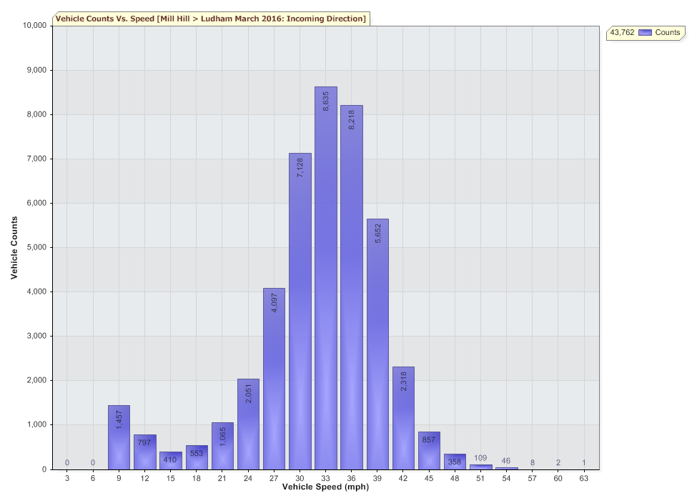
  - Cllr Iddon. Meeting regarding hedge on recreation ground beside TT table. Cllr Iddon explained that he had met with Iris Buckland to discuss the hedge on the recreation ground and that he had explained to her that the Parish Council would not be undertaking work to the hedge. He also noted that there was an area nearer to the playground on the hedgeline where children and teenagers were hiding within the hedge. Councillors agreed that there was no purpose in removing or clearing out that area of hedge as children / teenagers would simply find a new ‘den’ and that no harm was being caused by them and no complaints had been made

- Parishioners’ Matters: The meeting was adjourned at 7.39 pm for public participation
  - District Councillor report: District Councillor Barbara Mcgoun explained that herself, Councillor Iddon and Scott Martin from NCC would be holding a working party to discuss the boat waste. She also reported that a new vicar would shortly be joining the benefice. She also congratulated the Chairman on the success of the Sam2 on Swan Corner
  - County Councillor Allison Bradnock was not present at the meeting

  - Public Participation.

A member of the public asked if the Parish Council could assist the Village Hall with the outstanding sum of £72 which Vodafone had assured the Village Hall they would refund. The Chairman agreed to help with this.

Dave Young (Leader of the Parish Plan Review Team) explained that the team were working on ways to get people of the parish involved. He also noted that flyers would be included in the Horning Reach. The Chairman thanked Mr Young very much indeed and congratulated him on a very enthusiastic start to the revised plan

The meeting was reconvened at 7.50pm

- Agenda items
  - Price for hiring out SAM2 sign (per month). The Parish Council agreed that it was too early to consider hiring out the SAM2
  - Defibrillator maintenance including Arthur Edmunds’ defibrillator. The Chairman explained that he felt that the ownership and maintenance of the defibrillators would become tangled in complexity. He therefore suggested that the Parish Council gift the two defibs and cabinets to the New Inn and the Ferry Marina, and gift the cabinet to the Village Hall. Betty Woodcock was present at the meeting and confirmed that this would suit the Village Hall well. Cllr Iddon offered to discuss the defibrillators with the New Inn and the Ferry Marina and to revert at the next meeting
  - Consideration of what is required for the Quality Council status and a timeline put in place. The Clerk explained the requirements for Quality Council status, much of which involved work on the website, which The Clerk would do over the coming weeks
  - HBS bids – suggestions
    - Water tank at allotments. This bid could be worked on by an allotment committee
    - Fencing around the playground, possibly with a kissing gate. Cllr Avellino would put this bid in to the HBS the same as in 2015 but with some clarity regarding the reasons for the lack of gate within the bid. Cllr Avellino would send the bid around Councillors for their input before submitting the bid
  - To consider instructing the work on footpaths 1 and 2, for which the Parish Council recently approved a 50:50 Parish Partnership grant, which was subsequently agreed by Norfolk County Council (three letters of support have been received). The Parish Council agreed unanimously to ask NCC Highways to go ahead with this work. The Clerk would speak with Philip Schramm to organise the work and would add the £875 to the following agenda
  - To nominate a Parish Councillor with responsibility for allotments, including the allotment competition, following Diane Moore’s resignation. The Parish Council agreed that the allotments should be self-managed. The Chairman offered to speak with Geoff Evans about this
- To plan items for the next agenda
  - Gifting of defibrillators
  - Co-option of a Parish Councillor

- To list items for the Horning Reach Parish News:

  - 1st May parking regulations change
  - Clerk email address change
  - Co-option of Parish Councillor
  - Quality Council
  - Annual Parish Meeting

- At the Chairman’s discretion

- Closure of meeting at 9.05pm and details of the next meetings:

  - Monday 16th May – ANNUAL PARISH COUNCIL MEETING
  - Wednesday 4th May – ANNUAL PARISH MEETING (VH ANNEX)
  - Monday 13th June – June Parish Council meeting

