HORNING PARISH COUNCIL

Minutes of the Parish Council Meeting
held on Monday 16th May 2016

Present:
Cllr I Davis
Cllr P Iddon
Cllr K Smith
Cllr C Smith
Cllr A Darby
Cllr P Kibler
Cllr P Avellino
Cllr R Martin

Clerk / RFO: Jo Beardshaw

Number of Parishioners: 8

- Election of Chairman and Vice Chairman. Cllr Davis explained that he had enjoyed his role as Chairman of the Parish Council over the past year, but that the work commitments had meant that he had been unable to attend two meetings during the year. Cllr Davis stepped down from the position of Chairman. He asked for nominations for the position of Chairman. Cllr Iddon was nominated, seconded and unanimously voted as Chairman of the Parish Council. Cllr Davis was nominated, seconded and unanimously voted as Vice Chairman of the Parish Council. Both Councillors signed their declarations as required
- Apologies. Apologies were received and accepted from Cllr Gilden. Cllr K Smith left the meeting following item 1 as she was unwell
- Declarations of Interest. None
- Minutes of the previous meeting. The minutes of the meeting on Monday 4th April 2016 were confirmed as a true and correct record, and were signed
The minutes of the Annual Parish Meeting were postponed until the June meeting

- To confirm Chairman of: the asset management committee, the finance committee and the planning committee. The following Chairman roles of committees were AGREED. Finance: Cllr Davis. Planning: Cllr Kibler. Asset Management: Cllr Avellino

- All members – confirmation of Financial Regulations, standing orders, code of conduct. These documents were all AGREED

- Actions from previous minutes:

- Ludham Bridge Moorings work. Cllr C Smith confirmed that he hoped that this work would begin before Christmas. Councillors held a discussion regarding liability if the quayheading were to degrade further but it was agreed that the summer would not degrade the quayheading significantly. Cllr Kilber agreed to look at the quayheading again in the coming week
- Defibrillators. The Chairman confirmed that all three defibrillators were now up and running in their cabinets. The Parish Council had written letters to the Village Hall and the Ferry Marina gifting their cabinets and defibrillators to them. The New Inn had not wished to take the gift so the defib and cabinet remained the property of the Parish Council. Cllr Davis confirmed that he would maintain and look after the defibrillator at the New Inn
- Boat Waste Update. The Clerk updated the Parish Council on the costs of bins (around £1000 per bin per year) and the cost of the pad for the bins to go on. Cllr Avellino offered to speak with Keith Buck to ask him to quote on the new pad.
- SAM2. Cllr Davis confirmed that he had applied for a site for the SAM2 sign up near Ludham Bridge but that he had been informed by NCC Highways that the Parish Council would not be allowed a sign on a 40 mph limit road. Cllr Davis noted that he intended to fight this point. Cllr Avellino reassured the Council that it was likely that NCC would allow the SAM2 to be positioned at Ludham Bridge after discussions.

- Correspondence

  - PCSO report. The PCSO had written to the Clerk with the latest police report, which was as follows. There have been 17 calls from the Horning area since your last meeting in April which I will summarise below; 4 calls for information purposes, 8 reports of rowdy or nuisance behaviour, 2 road related call, 1 report of suspicious circumstances, 1 call to assist ambulance, 1 call for a concern for safety. There has been 1 reported crime since your last meeting which was a criminal damage. The offender for this has been given a police caution.’ Noted
  - NCC. Footpath closure (570 metres South of Hall Road for a further 850 metres). Noted
  - NCC. Road Closure for Horning Fayre 21st August 2016. Noted
  - NCC. New communications cabinet (Broadband) The Avenue, beside 24 Norwich Road. Noted
  - NCC PROW officer. FP11. Low key surfacing works to muddy areas planned. The Clerk noted that Cllr Avellino had a further update on this and would cover it in her asset management report
  - Parishioner. Request (to NCC) to consider creating a footpath from Ludham Bridge to the footpath leading to Horning Hall on safety grounds. Councillors felt that this would be covered by the Three Rivers Way path.
  - David Bracey. Play Inspection booked for 11th July. Cllr Davis offered to undertake play inspection training. The Clerk would arrange this. The Inspection date was noted
  - Parishioner. Request for action regarding horses using footpaths in the village. The Chairman agreed that this item should be added to the Parish News
  - Carol Gilden. Green under sign – NCC have left in a state of disrepair. The Clerk would contact NCC to ask them to roll the green, and would contact Carol Gilden to ask her not to mow the green for the time being
  - Colin Boakes (HBS). Letter to the Parish Council. Mr Boakes had written to the Parish Council as follows:
Further to the 2016 Horning Boat Show on Saturday, I wanted to write to you personally and also on behalf of the Chairman & entire Organising Committee Organising Committee, to offer our most sincere thanks for your invaluable support.
We have already received a lot of positive feedback from exhibitors, visitors and village businesses and the success of this, our fourth Horning Boat Show is in no small measure due to the support that we receive from the Parish Council. The staging of the event is dependent upon our use of village facilities & for that we are extremely grateful.
The Organising Committee are delighted that the 2016 Show was another resounding success with a large & steady stream of visitors across what was a sunny albeit rather fresh spring day & that we have again raised a significant sum for distribution through the Horning Boat Show Community Fund.
We do hope that we can continue to count on your support for future Horning Boat Shows.
  - Mr M Turpin. Letter of resignation from the Parish Council. The Chairman thanked Cllr Turpin very much for his seven years of work on the Parish Council including 5 years as Chairman.

- Finances:
  - To confirm the Clerk as Responsible Finance Officer. AGREED
  - To receive confirmation of finances. This item was covered in iem 14f below
  - The following receipts were noted:
    - NNDC. Grant £390. Precept £7933

  - The following payments were authorised:
    - S/O. CGM Landscaping. £81.80 inc £13.63 VAT
    - DD. Clerk Pension £81.03. Parish Council contribution £57.88
    - Chq no 2191. Clerk salary and expenses. £557.12
    - Chq no 2192. Ralph Morris. Litter picking April. £130
    - Chq no 2193. Post Office Ltd. HMRC. Tax. £78.60
    - Chq no 2194. Norfolk County Council. FP1 and FP2 parish partnership work. £875
    - Chq no 2195. Anita Turpin. Flowers and bulbs for planters. £123.90
    - Chq no 2196. Horning Village Hall. Defibrillator electrician work. £204.14
    - Chq no 2197. Jo Beardshaw. Reimbursement of international payment to Medisol for defibrillator cabinets. £108 plus reimbursement of ‘buyaplan’ document for planning application for flagpole. £16.80. Total £124.80
    - Chq no 2198. Came and Company. £770.70
    - Chq no 2199. NALC. Subscription. £210.46
    - Chq no 2200. Carol Gilden. Grass cutting March. £50
    - Chq no 2201. URM UK Ltd. Glass recycling. £10.80 inc £1.80 VAT
    - Chq no 2202. Country Grounds Maintenance Ltd. Rolling of recreation ground. £294 inc £49 VAT
    - Chq no 2203. Ferry Marina Ltd. Electricity to defibrillator. £637.61 inc £106.27 VAT
    - Chq no 2204. Emery and Son electricians. Electricity to defibrillator at New Inn. £518.65 inc £86.44 VAT
    - Chq no 2205. Replacement for chq 2144 never cashed. Poppy Appeal. £50
- Planning:
  - Planning applications received
    - BA/20160145/FUL. The Staithe, Lower Street, Horning. Flagpole. Supported
    - BA/2016/0170/COND. Heron Cottage, Ferry Road. Variation of condition 2 of permission BA/2014/0228/CU. Cllr Kibler noted that this had already been agreed
    - BA/2016/0136/FUL. Cygnets Reach, Lower Street. Proposed single storey extension to front and side of boat shed. Cllr Kibler noted that this had already been agreed
    - BA/2016/0187/HOUSEH. The Boat House, Ferry Road. Car port. Cllr Kibler noted that this had already been agreed

  - Planning decisions received and noted:
    - NNDC. PF/16/0112. Land at Leeds Way. This application has been withdrawn. Noted

- Asset Management.
Cllr Avellino reported that Cllr Darby had taken £87.92 from the collection box, which the Clerk would bank. It was agreed that a further collection box could be put in place near the pump rather than relocating the existing collection box. Cllr Avellino would research costs for a collection box

- Parish Councillor reports. To receive any Parish Councillor reports
  - Cllr Davis reported that the SAM2 had returned to Swan corner. He agreed that he would try to configure the SAM2 sign so that it could record data but not flash, thus acting as a control measure
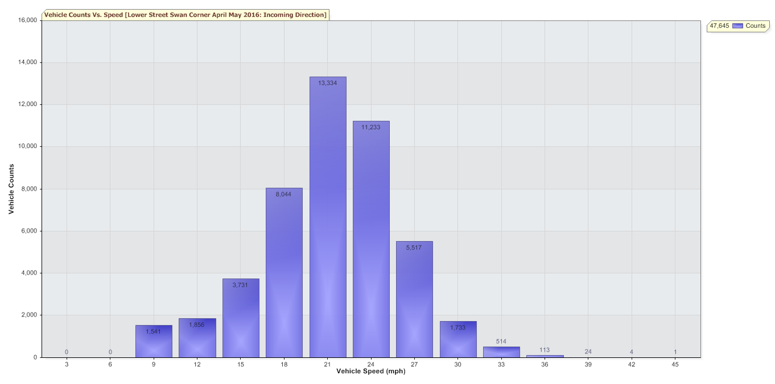
- Parishioners’ Matters: The meeting was adjourned at 7.52 pm for public participation
  - District / County Councillor report: District Councillor Barbara Mcgoun and County Councillor Allison Bradnock had sent their apologies as they were unable to attend the meeting

  - Public Participation.

The meeting was reconvened at 8.06 pm

- Agenda items
  - Consider approving the model code of conduct. This item had been covered above.
  - To confirm the purchase of two plaques, one for the playground and one for the flagpole. The Parish Council AGREED in principle to two plaques. One plaque beside the flagpole ‘sponsored by The Horning Boat Show’ and one plaque on the piece of equipment which had been funded by the Horning Boat Show ‘sponsored by The Horning Boat Show’.
  - To confirm that Councillors are satisfied with the current insurance policy. Cllr Martin AGREED to review this again to reflect the value of items owned by the Parish Council
  - To discuss replacement bins for boat waste. This was covered in item 7 above
  - To confirm the fixed asset register. AGREED. This would also be reviewed by the Finance Committee
  - To confirm the end of year finances. AGREED
  - To confirm Neal Sharpe as internal auditor for the year. AGREED

- To plan items for the next agenda
  - Governance Statement
  - Boat Waste update
  - Asset register update

- To list items for the Horning Reach Parish News:
  - Defib training

- At the Chairman’s discretion

- Closure of meeting at 8.42pm and details of the next meetings: 13th June 2016

